**Home Support Ideas in Mathematics for Parents and Students in the LKDSB**

***The intent of this newsletter is to highlight some of the amazing resources currently available to parents and students in the area of mathematics as we work together to support math learning while encouraging a love of math in your child. For direct links go to*** [***www.lkdsb.net***](http://www.lkdsb.net) ***Parents or Students tab and click Learning Resources on the left hand side.***

This site is designed for Ontario K-12 students and parents. It provides interactive electronic supports in the area of games, learning tools, activities, additional supports and FAQs. It is like a one-stop math shop for parents. 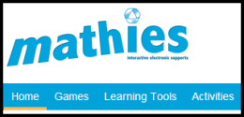<http://oame.on.ca/mathies/>

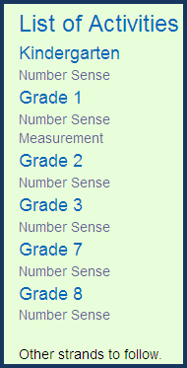Some of the highlights on the Mathies Website are **GAMES** which you can sort by topic or name, **LEARNING TOOLS** which makes available a variety of calculators, Geometer’s Sketchpad, and Linear Graphing, **ACTIVITIES** from the Student CLIPS and the Ontario Educator’s Resource Bank, **ADDITIONAL SUPPORTS** such as e-practice and Homework Help and **PARENTS HOME**. Each of these tabs provides numerous resources and interactive supports.

**ACTIVITIES: The Ontario Educational Resource Bank (OERB)** offers a number of digital activities and interactive learning resources, Kindergarten to Grade 12, for publicly funded schools. Your child’s teacher may direct you to a particular activity or you may explore on your own. The student login is ***lkdsbstudent*** and the password is ***oerbs***. <http://oame.on.ca/mathies/activities.html#CLIPS>

**HOMEWORK HELP** offers 24/7 resources and FREE tutoring available to Ontario students in Grades 7 to 10 from publicly funded schools.

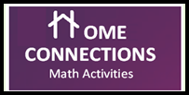**PARENTS: HOME CONNECTIONS** are printable Grade 1 to 6 mathematics activities to connect the learning in the classroom to experiences at home.

**TVO – Prime Radicals Educational Television**



Viewing math-based educational television programs can evolve into an interest in the underlying mathematics and can contribute to the development of greater interest and positive attitudes. [**http://www.tvokids.com/shows/primeradicals**](http://www.tvokids.com/shows/primeradicals)

**MATH TIPS FOR PARENTS** <http://www.edugains.ca/resources/SchoolLeader/IdeasForSchoolNewsletters/MathTipsforParents_Sept2014.pdf>

**NELSON MATHEMATICS:** One of the many resources teachers use in their classrooms to support the instruction of mathematics is Nelson Mathematics. <http://mathk8.nelson.com/companion.html>

****Available to you at home is the Parent Centre and Student Centre. When you click one of these options you will be directed to the textbook chapter number followed by the individual lesson number and concept. Your child’s teacher may direct you to a particular activity that would provide support and reinforcement of concepts taught in class. You may also wish to explore concepts on your own which are of particular interest to your child. In the **Student Centre** you will find three sub-headings.

***Surf More Math*** – Numerous fun math activities and games which are linked to the internet.

***Try It Out*** - These activities are more quiz-like and are scored at the end.

***Web Quests*** – These internet activities show how the math students learn in each chapter and the real world applications.

**Parent Centre** –The same links as above plus additional resources.